GBMV, TBMV, SBMV, HBMV & TBSV Functions – High Level Design
Version – 0.1
GBMV, TBMV, SBMV, HBMV & TBSV Functions – High Level Design 1
Banded Matrix – General representation 3
Row-major storage of band-matrix 4
Column-major storage of band-matrix 4
Derivation of column-major from row-major 5
GBMV – General Banded Matrix Vector Multiplication 6
REQUIREMENT 6
API 6
Double Precision DGBMV 6
Single Precision SGBMV 6
Single Complex CGBMV 7
Double Complex ZGBMV 7
DESIGN 7
Design: Row-major Non Transpose case (RM-NT) 8
Design: Row-major Transpose case (RM-T) 10
TBMV – Triangular Banded Matrix Vector Multiplication 12
REQUIREMENT 12
API 12
Double Precision DTBMV 12
Single Precision STBMV 12
Single Complex CTBMV 13
Double Complex ZTBMV 13
DESIGN 13
SBMV – Symmetric Banded Matrix Vector Multiplication 14
REQUIREMENT 14
API 14
Single Precision SSBMV 14
Double Precision DSBMV 14
Design 15
Column-major cases: 16
HBMV – Hermitian Banded Matrix Vector Multiplication 17
REQUIREMENT 17
API 17
Double Complex ZHBMV 17
Single Complex CHBMV 17
Design 17
TBSV – Triangular Banded Matrix Vector Solve 18
REQUIREMENT 18
API 18
Double Precision DTBSV 18
Single Precision STBSV 18
Double Complex ZTBSV 19
Single Complex CTBSV 19
DESIGN 19
DESIGN – Row Major - Lower Triangular (RM-L) 20
DESIGN – Row Major – Upper Triangular (RM-U) 21
DESIGN – Row Major – Lower Triangular Transpose (RM-LT) 22
DESIGN – Row Major – Upper Triangular Transpose (RM-UT) 23

Banded Matrix – General representation

Banded matrices are matrices with non-zero elements only along the diagonal area, such that

Where, $k_{l}$ is the sub-diagonal bandwidth,
$k_{u}$ is super-diagonal bandwidth

$$A_{1,1}$$ | $$A_{1,2}$$ | * | * | *
$$A_{2,1}$$ | $$A_{2,2}$$ | $$A_{2,3}$$ | * | *
$A_{3,1}$ | $$A_{3,2}$$ | $$A_{3,3}$$ | $$A_{3,4}$$ | *  $$N$$
* | $$A_{4,2}$$ | $$A_{4,3}$$ | $$A_{4,4}$$ | $$A_{4,5}$$
* | * | $$A_{5,3}$$ | $$A_{5,4}$$ | $$A_{5,5}$$
$$k_{u}$$
Since bandwidth is generally very small compared to width/height of the matrix, storing it as-it-is including the holes won’t be memory-efficient. So a banded matrix representation will only give information about the bands in the matrix
In this case $k_{l}$ = 2, $k_{u}$ = 1
and $N$ = 5
$$k_{l}$$
Figure 1: General banded matrix
$A_{x,y}$ - Sub-diagonal
$A_{x,y}$ - Diagonal
$A_{x,y}$ - Super-diagonal
$$bandwidth= k_{l}+k_{u}+ 1$$

Row-major storage of band-matrix
$$A_{1,1}$$ | $$A_{1,2}$$ | * | * | *
$$A_{2,1}$$ | $$A_{2,2}$$ | $$A_{2,3}$$ | * | *
$A_{3,1}$ | $$A_{3,2}$$ | $$A_{3,3}$$ | $$A_{3,4}$$ | *
* | $A_{4,2}$ | $$A_{4,3}$$ | $$A_{4,4}$$ | $$A_{4,5}$$
* | * | $A_{5,3}$ | $$A_{5,4}$$ | $A_{5,5}$  *
lda
* | * | $$A_{1,1}$$ | $$A_{1,2}$$
* | $$A_{2,1}$$ | $$A_{2,2}$$ | $$A_{2,3}$$
$$A_{3,1}$$ | $$A_{3,2}$$ | $$A_{3,3}$$ | $$A_{3,4}$$
$$A_{4,2}$$ | $$A_{4,3}$$ | $$A_{4,4}$$ | $$A_{4,5}$$
$$A_{5,3}$$ | $$A_{5,4}$$ | $$A_{5,5}$$ | *
*
*
$$N$$
*

$$lda≥(k_{l}+k_{u}+ 1)$$

Successive band of elements from each row of the original matrix represent a row in the band matrix

Column-major storage of band-matrix
* | $$A_{1,2}$$ | $$A_{2,3}$$ | $$A_{3,4}$$ | $$A_{4,5}$$
$$A_{1,1}$$ | $$A_{2,2}$$ | $$A_{3,3}$$ | $$A_{4,4}$$ | $$A_{5,5}$$
$$A_{2,1}$$ | $$A_{3,2}$$ | $$A_{4,3}$$ | $$A_{5,4}$$ | *
$$A_{3,1}$$ | $$A_{4,2}$$ | $$A_{5,3}$$ | * | *
$$A_{1,1}$$ | $A_{1,2}$ | * | * | *
$$A_{2,1}$$ | $$A_{2,2}$$ | $A_{2,3}$ | * | *
$$A_{3,1}$$ | $$A_{3,2}$$ | $$A_{3,3}$$ | $A_{3,4}$ | *
* | $$A_{4,2}$$ | $$A_{4,3}$$ | $$A_{4,4}$$ | $A_{4,5}$
* | * | $$A_{5,3}$$ | $$A_{5,4}$$ | $$A_{5,5}$$

$$N$$
*

$$lda$$

lda≥(kl+ku+ 1)
*
*
*

Successive band of elements from each column of the original matrix represent a column in the band matrix.

Derivation of column-major from row-major

$$CM ( A )$$
$$A$$
0 | 1 | * | *
2 | 3 | 4 | *
5 | 6 | 7 | 8
* | 9 | 10 | 11
* | 1 | 4 | 8
0 | 3 | 7 | 11
2 | 6 | 10 | *
5 | 9 | * | *
$CM ( A )$ in memory
* | 0 | 2 | 5 | 1 | 3 | 6 | 9 | 4 | 7 | 10 | * | 8 | 11 | * | *

$$k_{l}=2, { k}_{u}=1$$

$$RM ( A^{T} )$$
$$A^{T}$$

0 | 2 | 5 | *
1 | 3 | 6 | 9
* | 4 | 7 | 10
* | * | 8 | 11
* | 0 | 2 | 5
1 | 3 | 6 | 9
4 | 7 | 10 | *
8 | 11 | * | *
$RM ( A^{T} )$ in memory
* | 0 | 2 | 5 | 1 | 3 | 6 | 9 | 4 | 7 | 10 | * | 8 | 11 | * | *

$$k_{l}=1, { k}_{u}=2$$

In the above shown $4x4$ matrix, row-major representation of transpose matrix in memory is equivalent to column-major representation in memory. So given any column-major matrix, we can reuse the respective transposed row-major routine with $k_{l} \&{ k}_{u}$ values swapped.

Column-major $A_{(kl, ku )}$ | Row-major $A_{( ku, kl )}^{T}$
Column-major $A_{( kl, ku )}^{T}$ | Row-major $A_{(ku, kl )}$

GBMV – General Banded Matrix Vector Multiplication

REQUIREMENT
GBMV performs one of the matrix-vector operations

$y := alpha*A*x + beta*y$, or $y := alpha*OP(A)*x + beta*y$,

Where
- $x$ & $y$ are $N$ element vector
- $A$ is an $M*N$ band matrix
- Data Type can be “Single”, “Double”, “Single Complex” or “Double Complex”
- Ordering of data in the matrix can be either “Row Major” or “Column Major”
- $OP(A)$could be “Transpose” or “Conjugate (Hermitian) Transpose”
  - The conjugate transpose is applicable only for “Complex” variants of this function

API

Double Precision DGBMV
clAmdBlasStatus CLBLASAPI
clAmdBlasDgbmv(
clAmdBlasOrder order,
clAmdBlasTranspose trans,
size_t M,
size_t N,
size_t KL,
size_t KU,
cl_double alpha,
const cl_mem A,
size_t offa,
size_t lda,
cl_mem X,
size_t offx,
int incx,
cl_double beta,
cl_mem Y,
size_t offy,
int incy,
cl_uint numCommandQueues,
cl_command_queue *commandQueues,
cl_uint numEventsInWaitList,
const cl_event *eventWaitList,
cl_event *events);

Single Precision SGBMV
clAmdBlasStatus CLBLASAPI
clAmdBlasSgbmv(
clAmdBlasOrder order,
clAmdBlasTranspose trans,
size_t M,
size_t N,
size_t KL,
size_t KU,
cl_float alpha,
const cl_mem A,
size_t offa,
size_t lda,
cl_mem X,
size_t offx,
int incx,
cl_float beta,
cl_mem Y,
size_t offy,
int incy,
cl_uint numCommandQueues,
cl_command_queue *commandQueues,
cl_uint numEventsInWaitList,
const cl_event *eventWaitList,
cl_event *events);

Single Complex CGBMV
clAmdBlasStatus CLBLASAPI
clAmdBlasCgbmv(
clAmdBlasOrder order,
clAmdBlasTranspose trans,
size_t M,
size_t N,
size_t KL,
size_t KU,
cl_float2 alpha,
const cl_mem A,
size_t offa,
size_t lda,
cl_mem X,
size_t offx,
int incx,
cl_float2 beta,
cl_mem Y,
size_t offy,
int incy,
cl_uint numCommandQueues,
cl_command_queue *commandQueues,
cl_uint numEventsInWaitList,
const cl_event *eventWaitList,
cl_event *events);

Double Complex ZGBMV
clAmdBlasStatus CLBLASAPI
clAmdBlasZgbmv(
clAmdBlasOrder order,
clAmdBlasTranspose trans,
size_t M,
size_t N,
size_t KL,
size_t KU,
cl_double2 alpha,
const cl_mem A,
size_t offa,
size_t lda,
cl_mem X,
size_t offx,
int incx,
cl_double2 beta,
cl_mem Y,
size_t offy,
int incy,
cl_uint numCommandQueues,
cl_command_queue *commandQueues,
cl_uint numEventsInWaitList,
const cl_event *eventWaitList,
cl_event *events);

DESIGN

This section will only address the row-major version of Gbmv. All column-major variants can be derived from row-major as discussed above.
There are 2 versions of Gbmv that are to be designed separately. They are:
- Non- transpose case
- Transpose case

Design: Row-major Non Transpose case (RM-NT)

$$k_{l}$$
Workgroup 0
Workgroup 2
Workgroup 1
$$N$$
Last workgroup
$$k_{u}$$
Figure 2: Row-major non-transpose case of band matrix

Figure 2: Row-major non-transpose case of band matrix shows the parallel breakdown scheme for this case. Each work-group is assigned a group of rows, which carries out matrix-vector operation. As seen in Figure 2: Row-major non-transpose case of band matrix, the group of rows assigned to a work-group form a trapezium.
Accessing $A$ matrix using aligned vector-loads is possible but involves conditional logic that can hurt performance. Therefore, $A$ matrix can be loaded using scalar loads and vector-math can be performed on them. Thus, a logical 2D work-group of size $Y*H$ can handle $H*VECTOR_WIDTH$ number of columns and $Y$ number of rows at a given time.
A set of $H$ threads will work on a row. It will start at $SI$ and will loop for next $NE$ elements,
Where,

$SI$ - Starting Index for the row in the band-matrix
$NE$ - Number of Elements in the row
Let $row$ be zero-based index for the rows in the band-matrix, then

$SI=max⁡( k_{l}- row, 0 )$ And $NE=No.of subDiagonals+Diagonal+No. of superDiagonals$ in the $row$
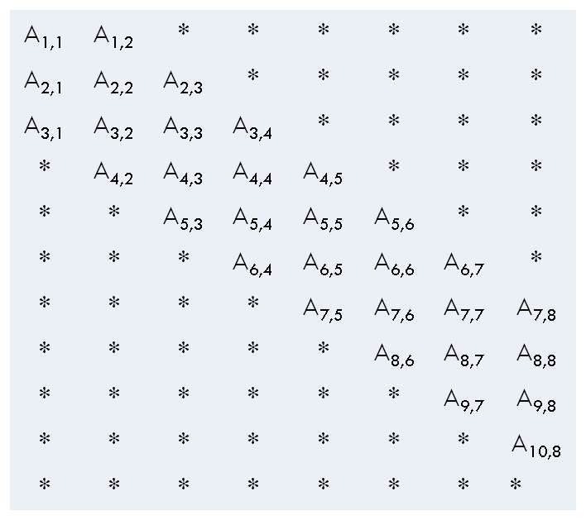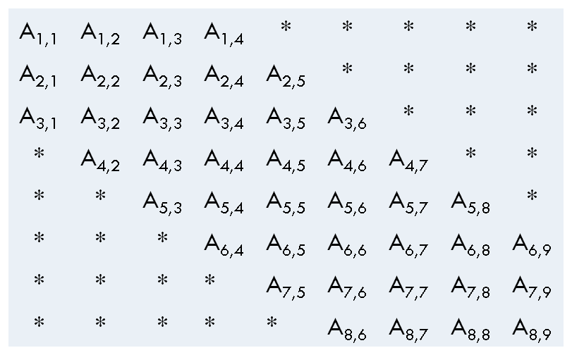
$$N>M$$
$$M>N$$

Consider the above matrices in row-major form. Calculation for number of sub-diagonal, diagonal & super-diagonal is as follows:
$$Diagonal=\left( row<N \right)? 1 :0$$
The diagonal component disappears after $N^{th}$ row
$$SuperDiagonal=max⁡[ 0,\min\left( k_{u} , N-1-row \right)]$$
When the last element in a row of a band is at the $N^{th}$ column, the super-diagonal component starts decreasing from there on. For such cases, the expression $\left(N-1-row \right)$ gives the number of super-diagonal elements in a given row. After $N$ rows, the super-diagonal component disappears.
$$SubDiagonal=\min\left( row , γ \right)$$
$$where, γ=max⁡[ 0 ,\min\left( δ, (N+k_{l}- row)\right) ]$$
$and,$ $δ=min⁡( k_{l} , N)$
Initially the sub-diagonal component grows which is given by $row$. Then it remains $δ$ for next set of rows. If $k_{l}>N$, then the max no. of sub-diagonals is limited to $N$, which is given by $δ$. In the next phase sub-diagonal component decreases which is given by $\left( N+k_{l}- row\right)$. After $(N+ k_{l})$ rows in a matrix where $M>N$, the sub-diagonal component disappears.
Note: Since the formulas involve $\max{\& min}$, all variables have to be of signed-integer type
Advantages:
- Successive blocks work on successive memory regions resulting in uniform memory pressure.
- Threads sharing the same column need access to the same element from $x$. The element can be loaded once into local memory and then re-used by all threads in the work-group. Local memory broadcast feature can be used.
- Threads sharing the same row load consecutive data elements from memory resulting in coalesced memory access

Design: Row-major Transpose case (RM-T)
Y
$$RM ( A )$$
$$A$$

0 | 2 | 5 | *
1 | 3 | 6 | 9
* | 4 | 7 | 10
* | * | 8 | 11
* | 0 | 2 | 5
1 | 3 | 6 | 9
4 | 7 | 10 | *
8 | 11 | * | *
Y[0]
Y[1]
Y[2]
Y[3]

Every anti-diagonal has to be accumulated for the respective element in Y

H
$$k_{l}$$
Last WG
WG 0
WG 1
Figure 3: Row-major transpose case of band matrix
$$k_{u}$$

Figure 3: Row-major transpose case of band matrix shows the parallel breakdown scheme for this case. Each work-group is assigned a group of anti-diagonal, which carries out matrix-vector operation. As seen in Figure 3: Row-major transpose case of band matrix, the group of rows assigned to a work-group form a parallelogram. A logical 2D work-group of size $Y*H$ can handle $H*VECTOR_WIDTH$ number of anti-diagonals and $Y$ number of elements in an anti-diagonal.
Column index for a given block in band-matrix is given by $δ$
$$BlockColIndex(δ)=BlockId*H+ k_{l}$$
The exact start column for a block is given by $BlockStartCol$. When $δ$ is more than $BandWidth(BW)$ , it always has to start from last column i.e. $\left(BW-1\right)$
$$BlockStartCol=\left(δ≥BW\right)?\left(BW-1\right):δ$$
The start row for a block is given by $BlockStartRow$. For first few blocks it always starts from first row. When $δ$ is more than $BW$ , there is an offset for the row given by $\left(δ-\left(BW-1\right)\right)$
$$BlockStartRow=max⁡( 0 , \left(δ-\left(BW-1\right)\right))$$

Advantages:
- Successive blocks work on successive memory regions resulting in uniform memory pressure.
- Threads working on a row need access to the same element of $X$. The element can be loaded once into local memory and then re-used by all threads in the work-group. Local memory broadcast feature can be used
- Threads sharing the same row load consecutive data elements from memory resulting in coalesced memory access

TBMV – Triangular Banded Matrix Vector Multiplication

REQUIREMENT
TBMV performs one of the matrix-vector operations

$x := A*x$, or $x := OP(A)*x$,

Where
- $x$ & $y$ are $N$ element vector
- $A$ is an $N*N$ unit, or non-unit, upper or lower triangular band matrix
- Data Type can be “Single”, “Double”, “Single Complex” or “Double Complex”
- Ordering of data in the matrix can be either “Row Major” or “Column Major”
- $OP(A)$ could be “Transpose” or “Conjugate (Hermitian) Transpose”
  - The conjugate transpose is applicable only for “Complex” variants of this function

API

Double Precision DTBMV
clAmdBlasStatus CLBLASAPI
clAmdBlasDtbmv(
clAmdBlasOrder order,
clAmdBlasUplo uplo,
clAmdBlasTranspose trans,
clAmdBlasDiag diag,
size_t N,
size_t K,
const cl_mem A,
size_t offa,
size_t lda,
cl_mem X,
size_t offx,
int incx,
cl_mem scratchBuff,
cl_uint numCommandQueues,
cl_command_queue *commandQueues,
cl_uint numEventsInWaitList,
const cl_event *eventWaitList,
cl_event *events);

Single Precision STBMV
clAmdBlasStatus CLBLASAPI
clAmdBlasStbmv(
clAmdBlasOrder order,
clAmdBlasUplo uplo,
clAmdBlasTranspose trans,
clAmdBlasDiag diag,
size_t N,
size_t K,
const cl_mem A,
size_t offa,
size_t lda,
cl_mem X,
size_t offx,
int incx,
cl_mem scratchBuff,
cl_uint numCommandQueues,
cl_command_queue *commandQueues,
cl_uint numEventsInWaitList,
const cl_event *eventWaitList,
cl_event *events);

Single Complex CTBMV
clAmdBlasStatus CLBLASAPI
clAmdBlasCtbmv(
clAmdBlasOrder order,
clAmdBlasUplo uplo,
clAmdBlasTranspose trans,
clAmdBlasDiag diag,
size_t N,
size_t K,
const cl_mem A,
size_t offa,
size_t lda,
cl_mem X,
size_t offx,
int incx,
cl_mem scratchBuff,
cl_uint numCommandQueues,
cl_command_queue *commandQueues,
cl_uint numEventsInWaitList,
const cl_event *eventWaitList,
cl_event *events);

Double Complex ZTBMV
clAmdBlasStatus CLBLASAPI
clAmdBlasZtbmv(
clAmdBlasOrder order,
clAmdBlasUplo uplo,
clAmdBlasTranspose trans,
clAmdBlasDiag diag,
size_t N,
size_t K,
const cl_mem A,
int offa,
size_t lda,
cl_mem X,
size_t offx,
int incx,
cl_mem scratchBuff,
cl_uint numCommandQueues,
cl_command_queue *commandQueues,
cl_uint numEventsInWaitList,
const cl_event *eventWaitList,
cl_event *events);

DESIGN

0 | 1 | 2 | *
* | 3 | 4 | 5
* | * | 6 | 7
* | * | * | 8
0 | * | * | *
1 | 2 | * | *
3 | 4 | 5 | *
* | 6 | 7 | 8

$$k_{l}=2, { k}_{u}=0$$
$$k_{l}=0, { k}_{u}=2$$
Lower triangular banded-matrix
Upper triangular banded-matrix

A triangular banded-matrix can imagined as a general banded-matrix with $k_{l} or k_{u}$ zero. So the same Gbmv design & routine can be reused in this case. Conditional defines can be added to accommodate Tbmv specific code. Such conditional code would be very minimal.

SBMV – Symmetric Banded Matrix Vector Multiplication

REQUIREMENT
SBMV performs one of the matrix-vector operations

$$y := alpha*A*x + beta*y$$
Where
- $x$ & $y$ are $N$ element vector
- $A$ is an $N*N$ band matrix
- Data Type can be “Single”, “Double”
- Ordering of data in the matrix can be either “Row Major” or “Column Major”

API

Single Precision SSBMV
clAmdBlasStatus CLBLASAPI
clAmdBlasSsbmv(
clAmdBlasOrder order,
clAmdBlasUplo uplo,
size_t N,
size_t K,
cl_float alpha,
const cl_mem A,
size_t offa,
size_t lda,
cl_mem X,
size_t offx,
int incx,
cl_float beta,
cl_mem Y,
size_t offy,
int incy,
cl_uint numCommandQueues,
cl_command_queue *commandQueues,
cl_uint numEventsInWaitList,
const cl_event *eventWaitList,
cl_event *events);

Double Precision DSBMV
clAmdBlasStatus CLBLASAPI
clAmdBlasDsbmv(
clAmdBlasOrder order,
clAmdBlasUplo uplo,
size_t N,
size_t K,
cl_double alpha,
const cl_mem A,
size_t offa,
size_t lda,
cl_mem X,
size_t offx,
int incx,
cl_double beta,
cl_mem Y,
size_t offy,
int incy,
cl_uint numCommandQueues,
cl_command_queue *commandQueues,
cl_uint numEventsInWaitList,
const cl_event *eventWaitList,
cl_event *events);

Design
0 | 1 | 3
1 | 2 | 4 | 6
3 | 4 | 5 | 7 | 9
* | 6 | 7 | 8 | 10
* | * | 9 | 10 | 11
* | * | 0
* | 1 | 2
3 | 4 | 5
6 | 7 | 8
9 | 10 | 11

Row-major representation of banded symmetric matrix A
Symmetric matrix A. given lower triangle

We can illustrate the problem with the above example, lower-triangular symmetric banded matrix. Accumulation of the row part can be divided 3 parts:
$$sum of subDiagonals+Diagonal+sum of superDiagonal$$
The same Gbmv code can be reused with conditional defines specific to Sbmv. The loop which iterates till the end of the row can be split into 3 parts:
- First loop for sub-diagonal elements
- One diagonal element
- Second loop for super-diagonal elements
In this lower-triangular matrix case, the second loop has to be modified to fetch super-diagonal elements.
The $startRow \& startCol$ for super-diagonals for a lower-triangular banded matrix is given by
$$startRow=row+1$$
$$startCol=(BW-2)$$
In the upper-triangular matrix case, the first loop has to be modified to fetch sub-diagonal elements.

0 | 1 | 2
1 | 3 | 4 | 5
2 | 4 | 6 | 7 | 8
* | 5 | 7 | 9 | 10
* | * | 8 | 10 | 11
0 | 1 | 2
3 | 4 | 5
6 | 7 | 8
9 | 10 | *
11 | * | *

Symmetric matrix A. given upper triangle
Row-major representation of banded symmetric matrix A

The $startRow \& startCol$ for sub-diagonals for a upper-triangular banded matrix is given by
$$startRow=max⁡( 0, \left(row-\left(BW-1\right)\right))$$
$$startCol=min⁡( \left(BW-1\right), row )$$

Column-major cases:

As derived earlier, column-major representation is equivalent to row-major transpose. We can reuse the row-major routines completely

Column-major upper $A$ | Row-major upper $A^{T}$ | Row-major lower A
Column-major lower $A$ | Row-major lower $A^{T}$ | Row-major upper A

HBMV – Hermitian Banded Matrix Vector Multiplication

REQUIREMENT
HBMV performs one of the matrix-vector operations

$$y := alpha*A*x + beta*y$$
Where
- $x$ & $y$ are $N$ element vector
- $A$ is an $N*N$ hermitian band matrix
- Data Type can be “Single Complex” or “Double Complex”
- Ordering of data in the matrix can be either “Row Major” or “Column Major”

API

Double Complex ZHBMV
clAmdBlasStatus CLBLASAPI
clAmdBlasZhbmv(
clAmdBlasOrder order,
clAmdBlasUplo uplo,
size_t N,
size_t K,
cl_double2 alpha,
const cl_mem A,
size_t offa,
size_t lda,
cl_mem X,
size_t offx,
int incx,
cl_double2 beta,
cl_mem Y,
size_t offy,
int incy,
cl_uint numCommandQueues,
cl_command_queue *commandQueues,
cl_uint numEventsInWaitList,
const cl_event *eventWaitList,
cl_event *events);

Single Complex CHBMV
clAmdBlasStatus CLBLASAPI
clAmdBlasChbmv(
clAmdBlasOrder order,
clAmdBlasUplo uplo,
size_t N,
size_t K,
cl_float2 alpha,
const cl_mem A,
size_t offa,
size_t lda,
cl_mem X,
size_t offx,
int incx,
cl_float2 beta,
cl_mem Y,
size_t offy,
int incy,
cl_uint numCommandQueues,
cl_command_queue *commandQueues,
cl_uint numEventsInWaitList,
const cl_event *eventWaitList,
cl_event *events);

Design

Hbmv follows design of Sbmv. Only a conditional conjugate has to be taken for sub-diagonal or super-diagonal.

TBSV – Triangular Banded Matrix Vector Solve

REQUIREMENT
TBSV performs one of the matrix-vector operations

$A*x=b$ or $A^{T}*x=b$

Where
- $x$ & $b$ are $N$ element vector
- $A$ is an $N*N$ unit, or non-unit, upper or lower triangular band matrix
- Data Type can be “Single”, “Double”, “Single Complex” or “Double Complex”
- Ordering of data in the matrix can be either “Row Major” or “Column Major”

API

Double Precision DTBSV
clAmdBlasStatus CLBLASAPI
clAmdBlasDtbsv(
clAmdBlasOrder order,
clAmdBlasUplo uplo,
clAmdBlasTranspose trans,
clAmdBlasDiag diag,
size_t N,
size_t K,
const cl_mem A,
size_t offa,
size_t lda,
cl_mem X,
size_t offx,
int incx,
cl_uint numCommandQueues,
cl_command_queue *commandQueues,
cl_uint numEventsInWaitList,
const cl_event *eventWaitList,
cl_event *events);

Single Precision STBSV
clAmdBlasStatus CLBLASAPI
clAmdBlasStbsv(
clAmdBlasOrder order,
clAmdBlasUplo uplo,
clAmdBlasTranspose trans,
clAmdBlasDiag diag,
size_t N,
size_t K,
const cl_mem A,
size_t offa,
size_t lda,
cl_mem X,
size_t offx,
int incx,
cl_uint numCommandQueues,
cl_command_queue *commandQueues,
cl_uint numEventsInWaitList,
const cl_event *eventWaitList,
cl_event *events);

Double Complex ZTBSV
clAmdBlasStatus CLBLASAPI
clAmdBlasZtbsv(
clAmdBlasOrder order,
clAmdBlasUplo uplo,
clAmdBlasTranspose trans,
clAmdBlasDiag diag,
size_t N,
size_t K,
const cl_mem A,
size_t offa,
size_t lda,
cl_mem X,
size_t offx,
int incx,
cl_uint numCommandQueues,
cl_command_queue *commandQueues,
cl_uint numEventsInWaitList,
const cl_event *eventWaitList,
cl_event *events);

Single Complex CTBSV
clAmdBlasStatus CLBLASAPI
clAmdBlasCtbsv(
clAmdBlasOrder order,
clAmdBlasUplo uplo,
clAmdBlasTranspose trans,
clAmdBlasDiag diag,
size_t N,
size_t K,
const cl_mem A,
size_t offa,
size_t lda,
cl_mem X,
size_t offx,
int incx,
cl_uint numCommandQueues,
cl_command_queue *commandQueues,
cl_uint numEventsInWaitList,
const cl_event *eventWaitList,
cl_event *events);

DESIGN

This section only addresses row-major data format. All column-major variants can be derived from row-major as discussed before.
There are 4 variants of Tbsv that needs to be separately designed:
- Lower triangle
- Upper triangle
- Lower triangle transpose
- Upper triangle transpose
Aspects like data-type of the matrix, or the matrix being unit or non-unit triangular does not affect the design.

DESIGN – Row Major - Lower Triangular (RM-L)
Triangle is solved first followed by the parallelogram below

1
H2
WG 0
WG 1
2
H
WG 2
3
$$N$$
4
Iteration 0
5
Figure 4: Banded matrix lower triangular matrix solve
Iteration 1
Iteration 2

The design is similar to that of Trsv discussed in earlier documentation. The Triangular system is solved iteratively. Iteration 2 is sequentially dependent on Iteration 1; Iteration 3 on Iteration 2 and so on. So the iterations have to be performed serially one after another.
Further, all Iterations perform 2 operations which are sequentially dependent. The first is solving the top-most dark-blue triangle followed by an update of RHS of the rows in the pale-blue parallelogram region.
The dark-blue triangle region can be solved only by one work-group. The only responsibility of the pale-blue rectangle part is to update the RHS of each individual row with the solved vectors available from the preceding dark-blue triangle part. The parallelogram-update region can be divided among the various workgroups of a kernel launch. Each workgroup works on one portion of the parallelogram region. Threads sharing the same row in a parallelogram load consecutive data elements from memory resulting in coalesced memory access.
Parallelogram part:

$$startRow=(H*\left(Iter+1\right))+ (BlockId*H2)$$
$$StartCol=\left(BW-1\right)- H-(BlockId*H2)$$
Triangle part:

$$startRow=H*Iter$$
$$StartCol=BW-1$$

DESIGN – Row Major – Upper Triangular (RM-U)

Iteration 2
Iteration 1
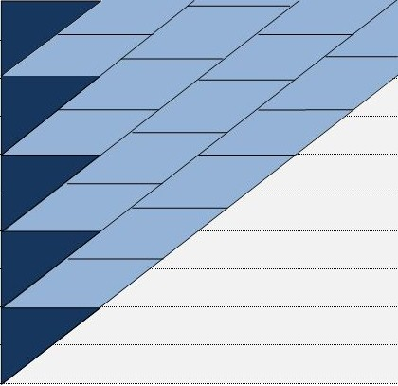
$$BW$$
Iteration 0
$$N$$
H2
H
WG 2
WG 1
WG 0
5
4
3
2
1
Figure 5: Banded matrix upper triangular matrix solve

The design is same as the lower triangular one. The only difference being iterating from bottom to top. The dark-blue triangle has to be solved first followed by light-blue parallelogram.
Triangle part:

$$startRow=\left(N-1\right)- (H*Iter)$$
$$StartCol=0$$

Parallelogram part:

$$startRow=\left(N-1\right)-[\left(H*\left(Iter+1\right)\right)+ \left(BlockId*H2\right)]$$
$$StartCol=\left(BlockId*H2\right)+ 1$$

DESIGN – Row Major – Lower Triangular Transpose (RM-LT)

5
4
Iteration 2
H
3
$$N$$
Iteration 1
H2
2
WG 0
WG 2
WG 1
Iteration 0
1
Figure 6: Banded matrix lower triangular transpose matrix solve

When lower triangle is transposed, it becomes upper-triangle with triangle tip on bottom-left of the banded matrix. So the parallelogram comes left to the triangle. This parallelogram can be divided among blocks, which are independent of each other. $H2$ threads will be spawned in a block, which will iterate $H$ times downward accumulating values for the corresponding $Y$ vector. Private memory can be used to accumulate values.
Triangle part:

$$startRow=\left(N-1\right)- (H*Iter)$$
$$StartCol=BW-1$$
Parallelogram part:

$$startRow=\left(N-1\right)-\left(H*\left(Iter+1\right)\right)$$
$$StartCol=\left(BW-1\right)- (\left(BlockId+1\right) *H2)$$

DESIGN – Row Major – Upper Triangular Transpose (RM-UT)

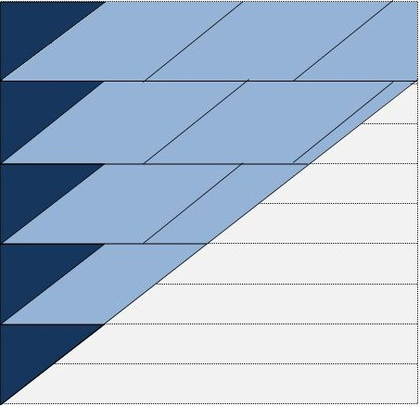
Iteration 2
Iteration 0
Iteration 1
WG 2
H2
WG 1
WG 0
H
$$N$$
1
2
3
4
5
Figure 7: Banded matrix upper triangular transpose matrix solve
The design is same as the lower triangular-transpose one. The only difference being iterating from top to bottom. The dark-blue triangle has to be solved first followed by light-blue parallelogram.
Parallelogram part:

$$startRow=H*Iter$$
$$StartCol=H+(H2*BlockId )$$
Triangle part:

$$startRow= (H*Iter)$$
$$StartCol=0$$

